Obseving the difference between inhaled and exhaled air.

- Set up the equipment as shown in the diagram:
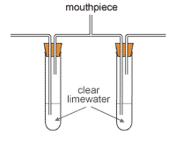

A B
- Gently breathe through the mouthpiece.
- Observe any changes in the two test tubes.

Questions

- Which tube (A or B) is testing the inhaled air? ______

- How do you know?
______________________________________________________________________________________________________________________________________

- Which tube is testing the exhaled air? ______

- How do you know?
______________________________________________________________________________________________________________________________________

- What gas was being tested for with the limewater? ________________

- What change do you expect to see if there is a positive result with the limewater?
___________________________________________________________________

- Briefly describe your observations below:
_________________________________________________________________________________________________________________________________________________________________________________________________________

- What information does this give us about the composition of inhaled and exhaled air?
_________________________________________________________________________________________________________________________________________________________________________________________________________

